Contents

1. PROJECT SETTINGS 2

1. Make “test” folder and initialize git on Git console 2

2. Link with GitHub repository 2

3. Pull Github repository contents 2

4. Create Spring Tool Suite workspace folder 2

5. Start Spring Tool Suite 3

6. Import project 3

7. Select your project folder 4

8. Set up git 5

9. Continuation of git set up process 6

10. Adding user name 8

11. Using git on Spring tool suite 8

12. Start the project 10

13. Start the browser 11

# PROJECT SETTINGS

## Make “test” folder and initialize git on Git console

This folder will contain project files, workspace should be in separate location.

Command: git init



Figure 1 - Git initialization on test folder

## Link with GitHub repository

Command:

git remote add origin https://github.com/milanmvujanic/test.git



Figure 2 - Linking with GitHub repository

## Pull Github repository contents

Command: git pull origin master

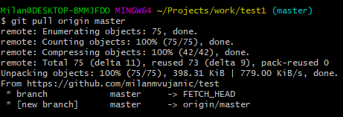

Figure 3 - Pulling GitHub repository contents

## Create Spring Tool Suite workspace folder

For example: C:\Users\Milan\sts-workspaces\work\test1

## Start Spring Tool Suite

Select workspace folder you just created.

Click on “Launch”.

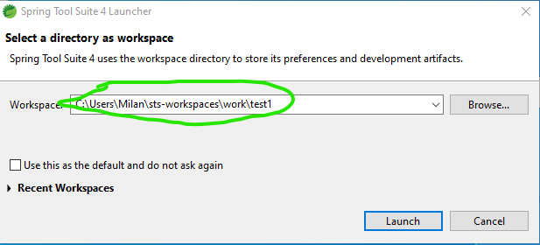

Figure 4 - Choosing Spring Tool Suite workspace

## Import project

Click on “File” -> “Import”, and then select “Existing maven project”.

Click on “Next”.

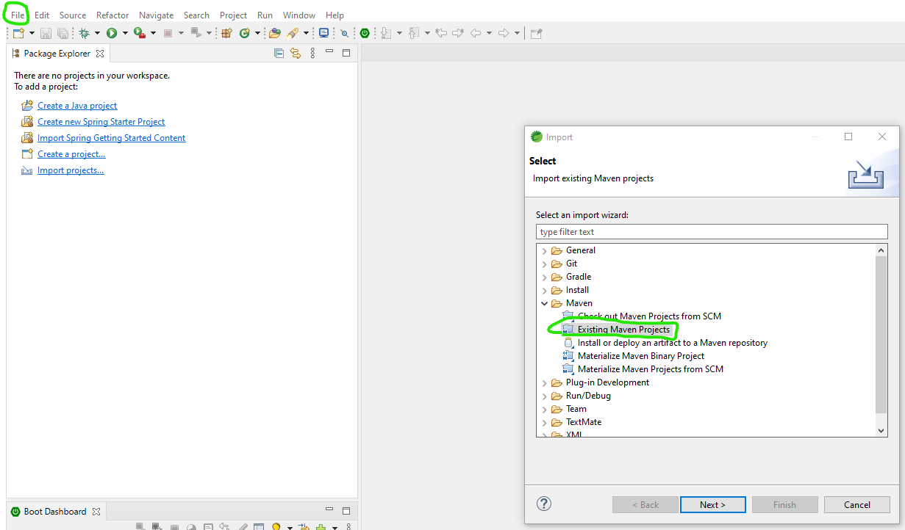

Figure 5 - Importing maven project

## Select your project folder

Select the folder location, and then click “Finish”.

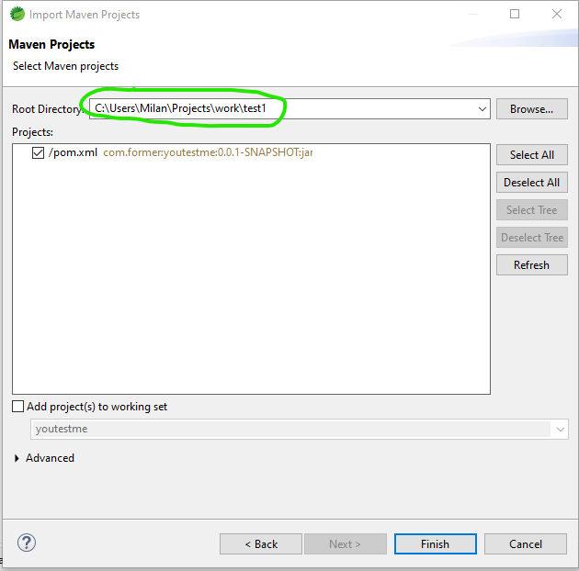

Figure 6 - Importing maven project

## Set up git

Select “Window” -> “Show view” -> “Other” and search for “git”.

Select “Git Repositories” and “Git staging”.

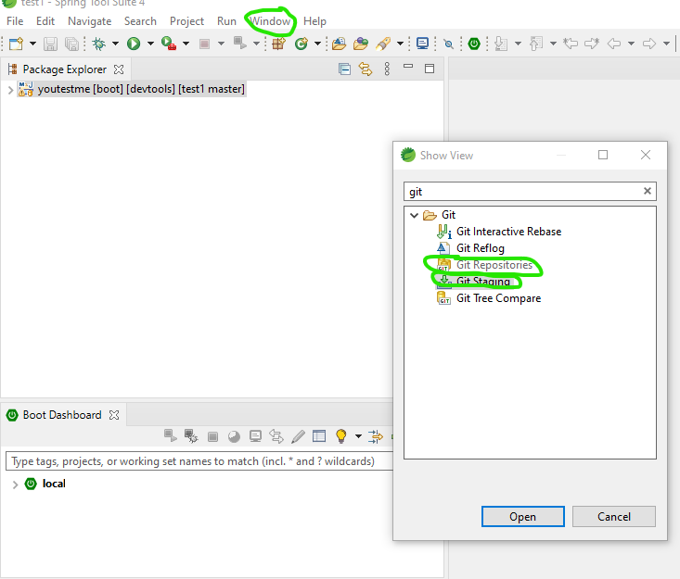

Figure 7 - Showing git windows

## Continuation of git set up process

Right-click on the repository, and select “Properties” option.

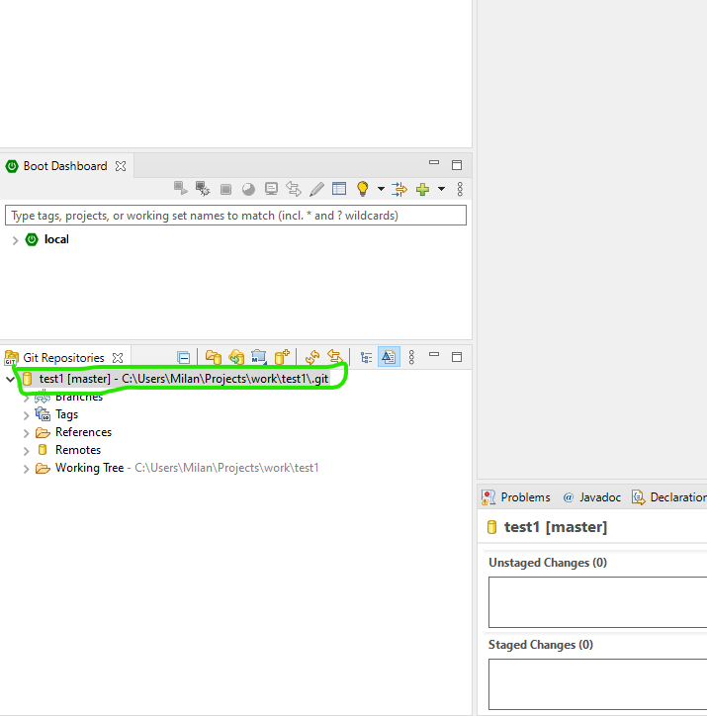

Figure 8 - Setting up credentials

Click on “Add Entry…”.

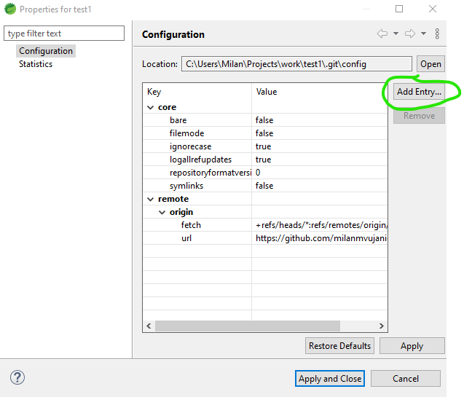

Figure 9 - Git set up

## Adding user name

Enter “user.email” in the first field, and your email in the second field.

Click on “Add”.

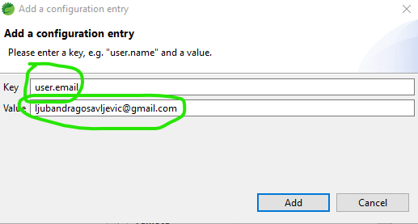

Figure 10 - Adding github credentials

## Using git on Spring tool suite

Changed files will be listed in “Unstaged changes” window.

Click on “++” symbol to add them all.

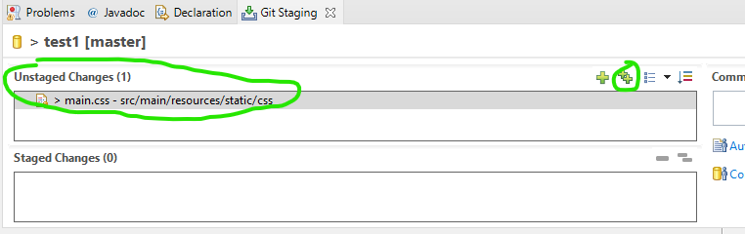

Figure 11 - Saving changes

Then, changes will be staged, you need to enter commit message.

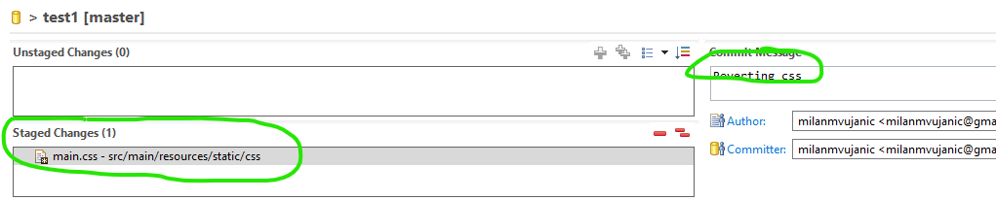

Figure 12 - Changes are staged

By clicking on “Commit and Push” you will save changes both on your local repository and on Github repository.

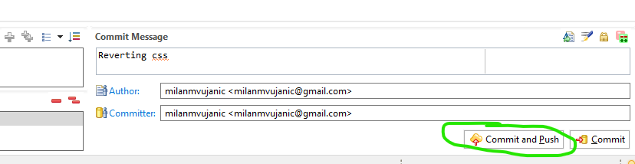

Figure 13 - Saving changes

## Start the project

Right-click on the project, select “Run as” -> “Spring Boot App”.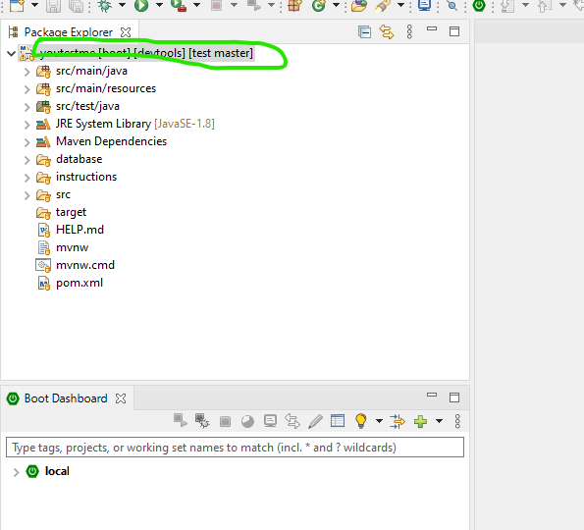

Figure 14 - Running application

## Start the browser

On the Browser type “localhost:8081/index”.

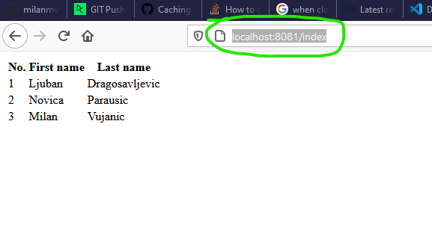

Figure 15 - Strarting on browser